# **INDEX**

|  |  |
| --- | --- |
| **Programs** | **Remarks** |
| 1. Write a program for Playfair cipher. |  |
| 1. Write a program for Caesar cipher. |  |
| 1. Write a program for Railfence cipher. |  |
| 1. Write a program for Vignere cipher. |  |
| 1. Write a program to show how message has been securely transferred through cryptography. |  |
| 1. Write a program for asymmetric cipher by using Extended Euclidean Theorem. |  |

# **PLAYFAIR CIPHER**

#include<stdio.h>

#include<conio.h>

#include<ctype.h>

int check(char table[5][5],char k)

{

int i,j;

for(i=0;i<5;++i)

for(j=0;j<5;++j)

{

if(table[i][j]==k)

return 0;

}

return 1;

}

int main()

{

int i,j,key_len;

char table[5][5];

for(i=0;i<5;++i)

for(j=0;j<5;++j)

table[i][j]='0';

printf("**********Playfair Cipher************\n\n");

printf("Enter the length of the Key: ");

scanf("%d",&key_len);

char key[100];

printf("Enter the Key: ");

for(i=-1;i<key_len;++i)

{

scanf("%c",&key[i]);

if(key[i]=='j')

key[i]='i';

}

int flag;

int count=0;

// inserting the key into the table

for(i=0;i<5;++i)

{

for(j=0;j<5;++j)

{

flag=0;

while(flag!=1)

{

if(count>key_len)

goto l1;

flag=check(table,key[count]);

++count;

}// end of while

table[i][j]=key[(count-1)];

}// end of inner for

}// end of outer for

l1:printf("\n");

int val=97;

//inserting other alphabets

for(i=0;i<5;++i)

{

for(j=0;j<5;++j)

{

if(table[i][j]>=97 && table[i][j]<=123)

{}

else

{

flag=0;

while(flag!=1)

{

if('j'==(char)val)

++val;

flag=check(table,(char)val);

++val;

}// end of while

table[i][j]=(char)(val-1);

}//end of else

}// end of inner for

}// end of outer for

printf("The table is as follows:\n");

for(i=0;i<5;++i)

{

for(j=0;j<5;++j)

{

printf("%c ",table[i][j]);

}

printf("\n");

}

int l=0;

printf("\nEnter the length of plain text.(without spaces) ");

scanf("%d",&l);

printf("\nEnter the Plain text. ");

char p[100];

for(i=-1;i<l;++i)

{

scanf("%c",&p[i]);

}

for(i=-1;i<l;++i)

{

if(p[i]=='j')

p[i]='i';

}

printf("\nThe replaced text(j with i)");

for(i=-1;i<l;++i)

printf("%c ",p[i]);

count=0;

for(i=-1;i<l;++i)

{

if(p[i]==p[i+1])

count=count+1;

}

printf("\nThe cipher has to enter %d bogus char.It is either 'x' or 'z'\n",count);

int length=0;

if((l+count)%2!=0)

length=(l+count+1);

else

length=(l+count);

printf("\nValue of length is %d.\n",length);

char p1[100];

//inserting bogus characters.

//char temp1;

int count1=0;

for(i=-1;i<l;++i)

{

p1[count1]=p[i];

if(p[i]==p[i+1])

{

count1=count1+1;

if(p[i]=='x')

p1[count1]='z';

else

p1[count1]='x';

}

count1=count1+1;

}

//checking for length

//char bogus;

if((l+count)%2!=0)

{

if(p1[length-1]=='x')

p1[length]='z';

else

p1[length]='x';

}

printf("The final text is:");

for(i=0;i<=length;++i)

printf("%c ",p1[i]);

char cipher_text[100];

int r1,r2,c1,c2;

int k1;

for(k1=1;k1<=length;++k1)

{

for(i=0;i<5;++i)

{

for(j=0;j<5;++j)

{

if(table[i][j]==p1[k1])

{

r1=i;

c1=j;

}

else

if(table[i][j]==p1[k1+1])

{

r2=i;

c2=j;

}

}//end of for with j

}//end of for with i

if(r1==r2)

{

cipher_text[k1]=table[r1][(c1+1)%5];

cipher_text[k1+1]=table[r1][(c2+1)%5];

}

else

if(c1==c2)

{

cipher_text[k1]=table[(r1+1)%5][c1];

cipher_text[k1+1]=table[(r2+1)%5][c1];

}

else

{

cipher_text[k1]=table[r1][c2];

cipher_text[k1+1]=table[r2][c1];

}

k1=k1+1;

}//end of for with k1

printf("\n\nThe Cipher text is:\n ");

for(i=1;i<=length;++i)

printf("%c ",cipher_text[i]);

getch();

}

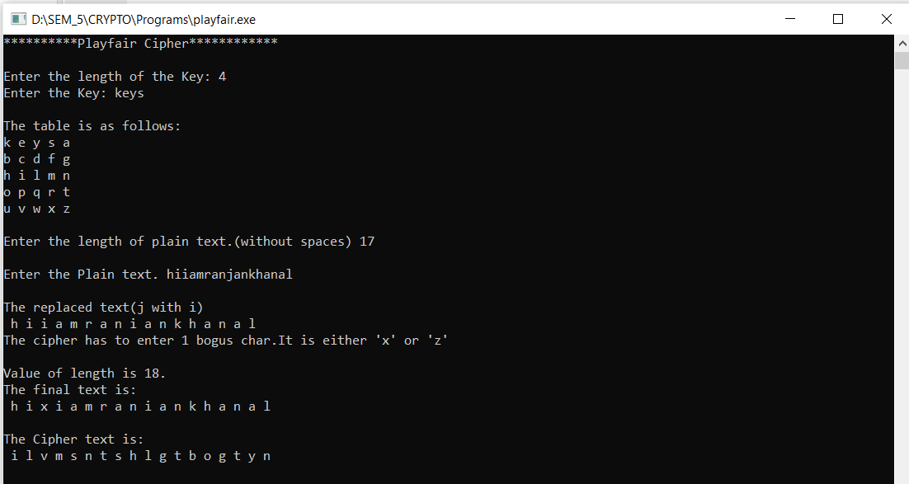­­­­

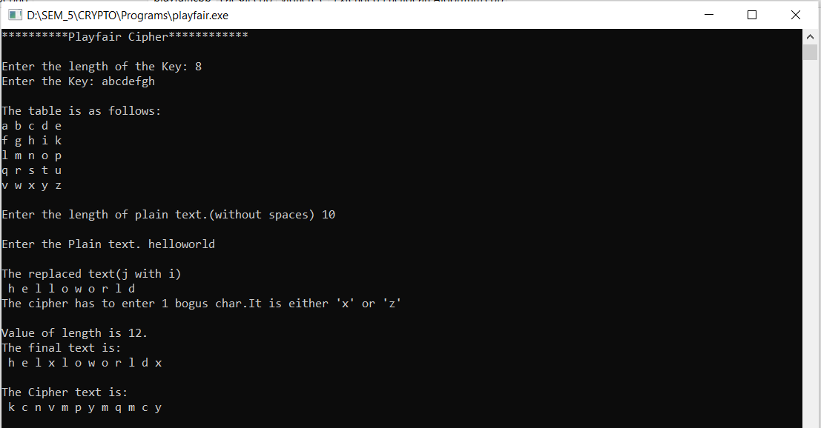

# **CAESAR CIPHER**

#include<stdio.h>

#include<conio.h>

#include<string.h>

int main()

{

char message[10],ch,c[10];

int key;

int i,len;

printf("Enter message:");

gets(message);

printf("\nEnter key:");

scanf("%d",&key);

// len=strlen(message);

// message[len]='\0';

for(i=0;i<strlen(message);i++)

{

ch=message[i];

if(ch>='a' && ch <='z')

{

ch=ch+key;

if (ch>'z')

ch=ch-26;

}

else if(ch>='A'&& ch<='Z')

{

ch=ch+key;

if (ch>'z')

ch=ch-26;

}

c[i]=ch;

}

c[i]='\0';

printf("\nCipher text:%s",c);

}

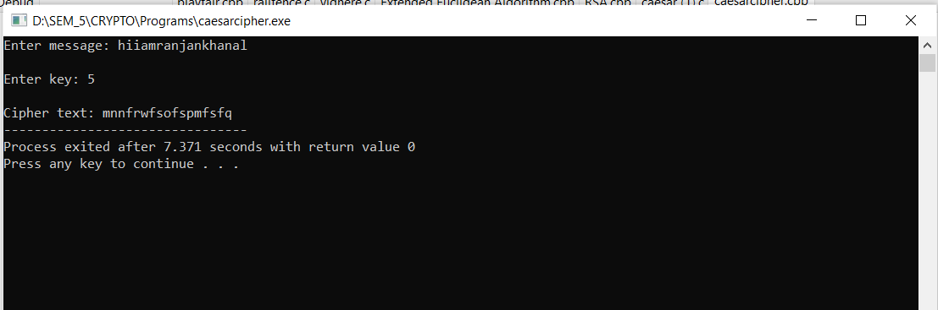

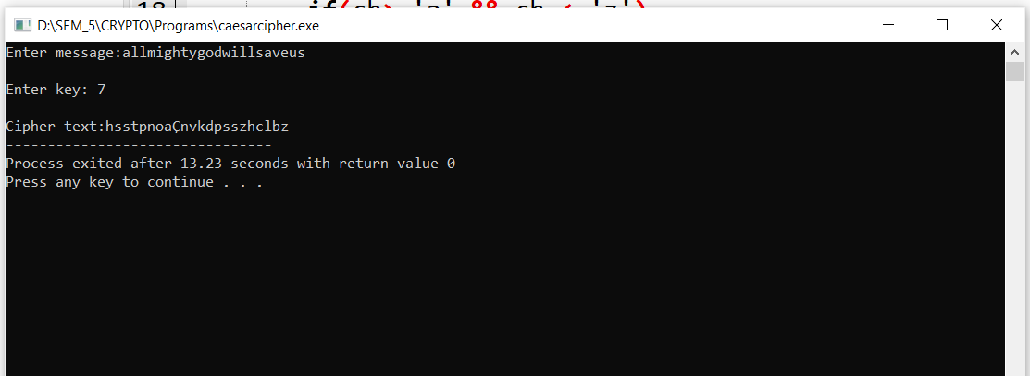

# **RAIL-FENCE CIPHER**

//Rail Fence Cipher

#include<iostream>

#include<string>

using namespace std;

class RailFence{

public:

int nrow,ncol;

int getKey(){

int key;

cout<<"Enter the Key (number of rails) \n";

cin>>key;

return key;

}

string getMessage(){

string msg;

cout<<"Enter the message \n";

cin.ignore();

getline(cin,msg);

return msg;

}

void encrypt(string msg, int key){

// creating a matrix to encrypt msg with key

// key = rows , length of msg=no. of characters = columns

nrow= key;

ncol= msg.length();

char rail_matrix[nrow][ncol];

// filling the rail matrix with ^ symbol

for (int i=0; i < nrow; i++) {

for (int j = 0; j < ncol; j++){

rail_matrix[i][j] ='^';

}

}

// to find the direction

bool downward = false;

int r = 0, c = 0;

string ciphertext;

for (int i=0; i < msg.length(); i++) {

// checking the direction of flow

// reverse the direction if the top or bottom rail is just filled

if (r == 0 || r == key-1)

downward = !downward;

// filling with characters in the plaintext

rail_matrix[r][c++] = msg[i];

// find the next row using direction

downward ?r++ : r--;

}

//to print the rail matrix

for (int i=0; i < nrow; i++) {

for (int j = 0; j < ncol; j++){

cout<< rail_matrix[i][j]<<" ";

}

cout<<"\n";

}

// generating the ciphertext using the rail_matrix

for (int i=0; i < key; i++) {

for (int j=0; j < msg.length(); j++) {

if (rail_matrix[i][j]!='^')

ciphertext.push_back(rail_matrix[i][j]); //appending a character

}

}

cout<<"\n The Ciphertext is:::> "<<ciphertext<<"\n";

}

void decrypt(string msg, int key){

// creating a matrix to encrypt msg with key

// key = rows , length of msg=no. of characters = columns

nrow= key;

ncol= msg.length();

char rail_matrix[nrow][ncol];

string plaintext;

// filling the rail matrix with ^ symbol

for (int i=0; i < nrow; i++) {

for (int j = 0; j < ncol; j++){

rail_matrix[i][j] ='^';

}

}

// to find the direction

bool downward;

int r = 0, c= 0;

// marking the places with '~'

for (int i=0; i < msg.length(); i++) {

// check the direction of flow

if (r == 0)

downward = true;

if (r == key-1)

downward = false;

// place the marker

rail_matrix[r][c++] = '~';

// find the next row using direction flag

downward?r++ : r--;

}

// filling the rail matrix

int indx = 0;

for (int i=0; i<key; i++) {

for (int j=0; j<msg.length(); j++) {

if (rail_matrix[i][j] == '~' && indx<msg.length())

rail_matrix[i][j] = msg[indx++];

}

}

// reading the matrix in zig-zag order to get the plaintext

r = 0, c = 0;

for (int i=0; i< msg.length(); i++)

{

// check the direction of flow

if (r == 0)

downward = true;

if (r == key-1)

downward = false;

// checking the marker

if (rail_matrix[r][c] != '~')

plaintext.push_back(rail_matrix[r][c++]); //appending

// finding the next row using direction flag

downward?r++: r--;

}

cout<<"The Plaintext is:::>"<<plaintext<<"\n";

}

};

int main(){

cout<<" =====Rail Fence Cipher===== \n";

int choice;

char more;

RailFence rf;

int k;

string m;

do{

cout<<"Enter\n 1 for ENCRYPTION,\n 2 for DECRYPTION and\n 3 for EXIT \n";

cin>>choice;

switch(choice){

case 1:

k= rf.getKey();

m= rf.getMessage();

rf.encrypt(m,k);

break;

case 2:

k= rf.getKey();

m= rf.getMessage();

rf.decrypt(m,k);

break;

case 3:

break;

default:

cout<<"\n INVALID CHOICE! \n";

}

cout<<"\n Do you want to perfrom more ENCRYPTION/DECRYPTION ? (y/n)\n ";

cin>>more;

}

while(more=='y'|| more=='Y');

cout<<"\n\n Thank You! \n\n";

}

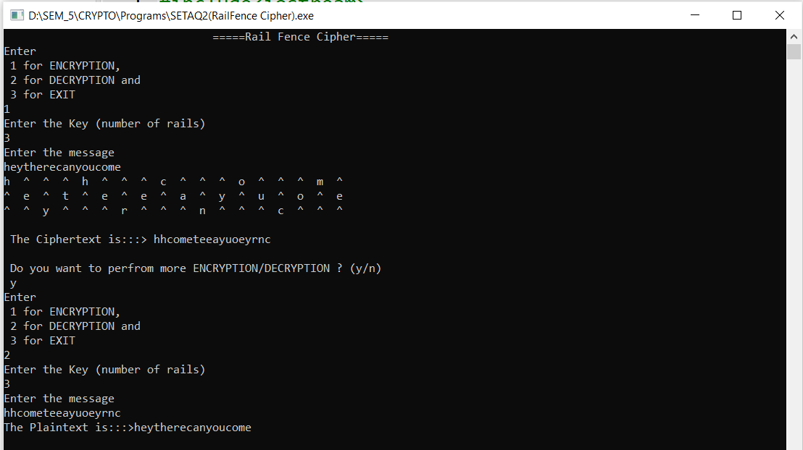

**VIGNERE CIPHER**

#include<stdio.h>

#include<string.h>

int main(){

char msg[] = "HIIAMRANJANKHANAL";

char key[] = "HELLO";

int msgLen = strlen(msg), keyLen = strlen(key), i, j;

char newKey[msgLen], encryptedMsg[msgLen], decryptedMsg[msgLen];

//generating new key

for(i = 0, j = 0; i < msgLen; ++i, ++j){

if(j == keyLen)

j = 0;

newKey[i] = key[j];

}

newKey[i] = '\0';

//encryption

for(i = 0; i < msgLen; ++i)

encryptedMsg[i] = ((msg[i] + newKey[i]) % 26) + 'A';

encryptedMsg[i] = '\0';

//decryption

for(i = 0; i < msgLen; ++i)

decryptedMsg[i] = (((encryptedMsg[i] - newKey[i]) + 26) % 26) + 'A';

decryptedMsg[i] = '\0';

printf("Original Message:%s", msg);

printf("\nKey:\n%s", key);

printf("\nNew Generated Key:\n%s", newKey);

printf("\nEncrypted Message:\n%s", encryptedMsg);

printf("\nDecrypted Message:\n%s", decryptedMsg);

return 0;

}

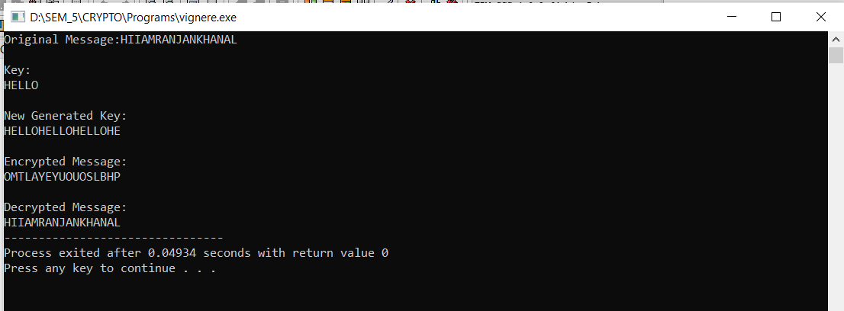

**MONOALPHABETIC SUBSTITUTION CIPHER**

#include<iostream>

#include<conio.h>

#include<string.h>

#include<stdlib.h>

using namespace std;

char p[100], c[100],k[100];

int i,j,index;

void upcipher();

void lowcipher();

int check_unique(char k[],int i)

{

for(j=0;j<i;j++)

{

if(k[j]==k[i])

{

return (1);

}

else

{

return(0);

}

}

}

void upcipher()

{

int u;

cout<<"\n Plaintext: ";

cin>>p;

cout<<"\n Enter key: "<<endl;

for(i=0; i<26; i++)

{

loop:

cout<<" "<<char(i+65)<<"--->";

cin>>k[i];

u=check_unique(k,i);

if(u==1)

{

cout<<"\n Enter unique key";

goto loop;

}

}

for(i=0;i<strlen(p);i++)

{

index=p[i]-65;

c[i]=k[index];

}

cout<<"\n Ciphertext: "<<c;

}

void lowcipher()

{

int u;

cout<<"\n Enter plaintext: ";

cin>>p;

cout<<"\n Enter key: "<<endl;

for(i=0; i<26; i++)

{

loop:

cout<<" "<<char(i+97)<<"--->";

cin>>k[i];

u=check_unique(k,i);

if(u==1)

{

cout<<"\n Enter unique key";

goto loop;

}

}

for(i=0;i<strlen(p);i++)

{

index=p[i]-97;

c[i]=k[index];

}

cout<<"\n Ciphertext: "<<c;

}

int main()

{

int ch;

cout<<"\n 1. Uppercase letters \n 2. Lowercase letters";

cout<<"\n Enter your choice: ";

cin>>ch;

if(ch==1)

upcipher();

else if (ch==2)

lowcipher();

else

cout<<"\n Invalid choice"; getch();

}

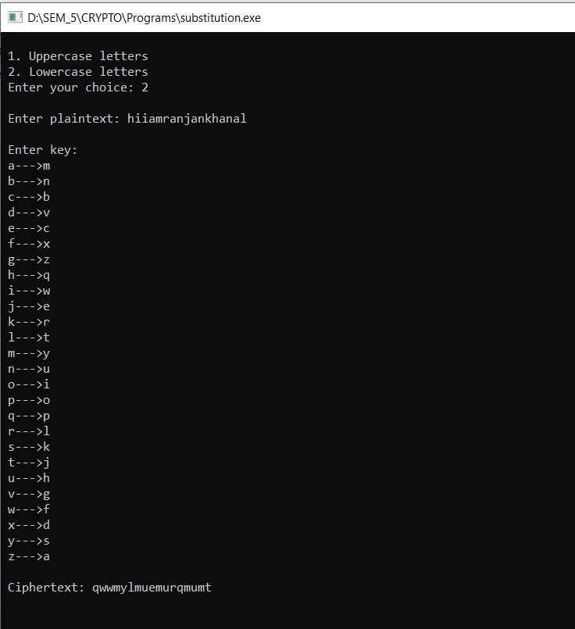

**ASSYMETRIC ALGORITHM (RSA)**

For demonstration values are relatively small compared to practical application

#include<stdio.h>

#include<math.h>

// Returns gcd of a and b

int gcd(int a, int h)

{

int temp;

while (1)

{

temp = a%h;

if (temp == 0)

return h;

a = h;

h = temp;

}

}

// Code to demonstrate RSA algorithm

int main()

{

// Two random prime numbers

double p = 3;

double q = 7;

// First part of public key:

double n = p*q;

// Finding other part of public key.

// e stands for encrypt

double e = 2;

double phi = (p-1)*(q-1);

while (e < phi)

{

// e must be co-prime to phi and

// smaller than phi.

if (gcd(e, phi)==1)

break;

else

e++;

}

// Private key (d stands for decrypt)

// choosing d such that it satisfies

// d*e = 1 + k * totient

int k = 2; // A constant value

double d = (1 + (k*phi))/e;

// Message to be encrypted

double msg = 12;

printf("Message data = %lf", msg);

// Encryption c = (msg ^ e) % n

double c = pow(msg, e);

c = fmod(c, n);

printf("\nEncrypted data = %lf", c);

// Decryption m = (c ^ d) % n

double m = pow(c, d);

m = fmod(m, n);

printf("\nOriginal Message Sent = %lf", m);

return 0;

}

